**Experiment 8**

**While considering the scope of the individual functionalities draw the use case diagram for each of it.**

A use case diagram is a visual representation that illustrates the interactions between actors (users or external systems) and a system under consideration. It provides a high-level view of the functionalities or features of a system from a user's perspective.

1. **Donor Registration:**

* **Use Case:** Register as a Donor
* **Actors:** Donor
* **Description:** Donors can register themselves by providing personal information such as name, contact details, blood type, and any relevant medical history.
* **Use Case Diagram:**
  + **Actor:** Donor
  + **Use Case:** Register as a Donor

1. **Health Screening:**

* **Use Case:** Undergo Health Screening
* **Actors:** Donor, Medical Staff
* **Description:** Donors undergo medical checks to ensure they meet eligibility criteria for blood donation, including tests for blood pressure, hemoglobin levels, and other health parameters.
* **Use Case Diagram:**
* **Actors:** Donor, Medical Staff
* **Use Case:** Undergo Health Screening

1. **Blood Donation:**

* **Use Case:** Donate Blood
* **Actors:** Donor, Medical Staff
* **Description:** Donors physically donate blood under the supervision of medical professionals. This includes the actual blood collection process and any necessary post-donation care.
* **Use Case Diagram:**
* **Actors:** Donor, Medical Staff
* **Use Case:** Donate Blood

1. **Appointment Scheduling:**

* **Use Case:** Schedule Donation Appointment
* **Actors:** Donor, Administrative Staff
* **Description:** Donors can schedule appointments for blood donation at their convenience. This helps manage the flow of donors and resources at the donation center.
* **Use Case Diagram:**
* **Actors:** Donor, Administrative Staff
* **Use Case:** Schedule Donation Appointment

1. **Inventory Management:**

* **Use Case:** Manage Blood Inventory
* **Actors:** Administrative Staff
* **Description:** Administrative staff manage the inventory of donated blood, including storage, tracking, and distribution to hospitals or other facilities as needed.
* **Use Case Diagram:**
* **Actors:** Administrative Staff
* **Use Case:** Manage Blood Inventory

1. **Notification System:**

* **Use Case:** Notify Donors
* **Actors:** Administrative Staff
* **Description:** Donors may receive notifications regarding donation events, urgent blood needs, or updates on their donation status.
* **Use Case Diagram:**
* **Actors:** Administrative Staff
* **Use Case:** Notify Donors

1. **Reporting and Analytics:**

* **Use Case:** Generate Reports and Analytics
* **Actors:** Administrative Staff, Management
* **Description:** Administrative staff and management can generate reports and analyze data related to donor demographics, donation trends, inventory levels, and operational efficiency.
* **Use Case Diagram:**
* **Actors:** Administrative Staff, Management
* **Use Case:** Generate Reports and Analytics

Each of these use case diagrams outlines the interactions between actors and the system to accomplish specific functionalities within the blood donation project. 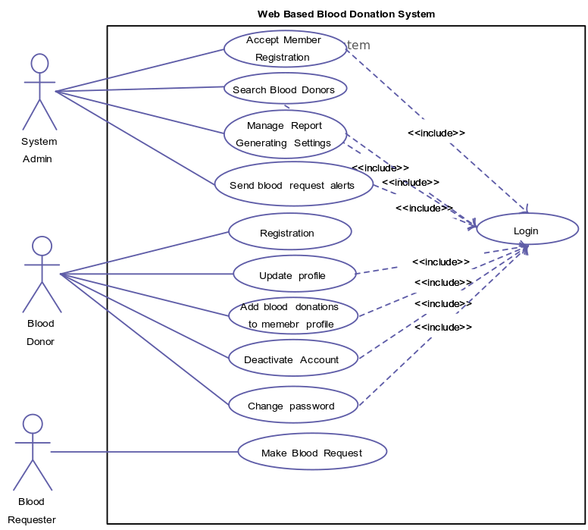

**Fig. Use Case Diagram**